**Brooklyn torah gazette**

**For parshas chaya sarah 5780**

Volume 4, Issue 10 (Whole Number 162) 25 Cheshvan 5780/ November 23, 2019

**Printed L’illuy nishmas Nechama bas R’ Noach, a”h**

For a free subscription, please forward your request to [***keren18@juno.com***](mailto:keren18@juno.com)

**The Challenge of Living**

**In a Generation of Tohu**

**By Daniel Keren**



A dedicated audience of men and women took advantage of a legal day off from work last week (Veterans Day) to participate in a half-day Flatbush Hakhel Yarchei Kallah at the Agudath Israel of Madison. Hakhel is a Flatbush-based organization devoted to promoting a greater awareness of Torah-true values in our community.

Rabbi Yisroel Reisman, mora d’asra of the host shul was the first speaker at the Veterans Day Hakhel Event and he focused his shiur (lecture) on Perakim (chapters) aleph (1) to ches (8) of Sefer Divrei Hayamim (Book of Chronicles). The title of his shiur was “The First 2000 Years.”

Divrei Hayamim can be divided into two parts. The first nine chapters consists primarily of lists of names of personalities up until Dovid Hamelelch (King David) and those who returned to Eretz Yisroel from Bavel (Babylonia.) Chapter 10 begins the second part of Divrei Hayamim by focusing on the story of Dovid Hamelech.

These first nine chapters don’t make Sefer Divrei Hayamim an easily appealing or interesting book to the average reader. Rabbi Reisman said that we need to understand why these names are recorded in the first perakim in the Book of Chronicles since they are also found in Sefer Bereishis.

Rabbi Reisman noted that there is no chronological order to the psalms that are included in Dovid Hamelech’s Sefer Tehillim. He also emphasized the fact that the amkus (depth) of Torah Bi’chasav (Written Torah) is something we can only marvel at.

All the tables of the families of mankind also have a great amkus, even though most of us can’t comprehend it. Indeed, the very first pasuk in Divrei Hayamim consists of just three words – “Adam, Sheis, Enosh.” They are first three generations of mankind. It is, Rabbi Reisman said, however a most profound verse.

Yet, when you read it, you will realize that it is one of the saddest of all pasukim in all of Tanach. Parents when they have children become a shutuf (partner) with Hakodesh Baruch Hu.

When Adam had with his wife Chava their first child (Kayin/Cain) after the creation of the world, he must have had great hopes for this child. Indeed Kayin was a great personality. He was the one who first thought of bringing a korban (sacrifice) to Hakodesh Baruch Hu, even before his father Adam could think of such an avodah (Divine service.)

Unfortunately for Kayin, his younger brother Hevel (Abel) also brought a korban which was superior to Kayin’s and was accepted whereas his older sibling’s offering was rejected by Hashem. . And that led to Kayin to become unfortunately the first murderer in the history of the world.

This tragedy devastated Adam Harishon who had placed such great hopes and expectations for his first son Kayin. Kayin and his offspring unfortunately were not interested in emulating Adam’s desire to follow the ways of Hakodesh Baruch Hu. Indeed for 135 years afterwards, Adam refrained from having more offspring [as a result of his disappointment in Kayin’s murder of Hevel.

Adam again was intimate with his wife Chava and they had a child whom he named Sheis (Seth) and Sheis’s first child was named Enosh. And who, Rabbi Reisman asked his audience was Enosh? He was the one who unfortunately turned much of the world’s population away from the proper worship of Hakodesh Baruch Hu and towards avodah zora (idol worship.)

Enosh erroneously believed and taught that although Hashem had indeed created the world, Hakodesh Baruch Hu had stepped back from His creation supposedly allowing His ministers (the sun, moon, stars and other forces of nature) to rule the world. Enosh taught that mankind should therefore worship these supposedly important forces of nature instead of directly placing one’s trust in Hakodesh Baruch Hu.

Adam Harishon was still alive at this time and we can only imagine how distraught the first man created in the image of G-d reacted to the failures of his grandson.

One lesson, Rabbi Reisman said, we should learn from this is that one should never abandon hope that the situation won’t change for the better in the next generation. In Sefer Divrei Hayamim itself, we read that Hizkiyahu, a righteous Jewish king (descendant of Dovid Hamelech) had a prophecy that he was destined to have a child (Menashe) who would create a terrible spiritual harm to the Jewish nation by promoting terrible avodah zorah. Therefore, Hizkiyahu didn’t want to get married in order to not have such an evil child.

The result was that Hizkiyahu was struck with a deathly illness. The Navi Yeshayahu told him that because of his sin in not fulfilling the important mitzvah of procreation, Hizkiyahu was going to die (both in this world and the next world.)

Rabbi Reisman pointed out that the lesson from this is that a Jew’s job is to fulfill the Torah and not worry about the consequences, for Hakodesh Baruch Hu can easily change those disappointments. Indeed, Hizkiyahu did teshuvah by marrying Yeshayahu’s daughter and Hashem gave him 15 more years of life.

It is not simple, Rabbi Reisman, to be a part of Klal Yisroel. Most people in the world today are not Jewish and even among those who are Jewish, most are unfortunately ignorant and don’t care to do these things (mitzvahs) that a Jew is obligated to do.

But our obligation is not to fall into despair, but to do what we must do and trust that Hakodesh Baruch Hu will do that which is needed to repair the situation. The Book of Chronicles teach us that there are plenty of human beings. Hakodesh Baruch Hu went through 2,000 years of Tohu (spiritual desolation) before finding an Avraham. G-d allowed plenty of seeming confusion. You go through eight chapters in Divrei Hayamim before you come to Dovid Hamelech.

The important lesson, Rabbi Reisman said, it to understand that one has to go through many less interesting names in order to discover an important spiritual giant such as Avraham and Dovid.

G-d didn’t create 2,000 years of tohu. Humans did. Our challenge in this world is to continue in the path of Adam, Sheis, Noach, Avrohom and Dovid and not get discouraged by the raging tohu around us.

Reprinted from the November 22, 2019 edition of the Flatbush Jewish Journal.

**18 Ways to More Effective**

**Prayer (Part 7)**

**By** [**Rabbi Moshe Meir Weiss**](https://www.jewishpress.com/author/rabbi-moshe-meir-weiss/)

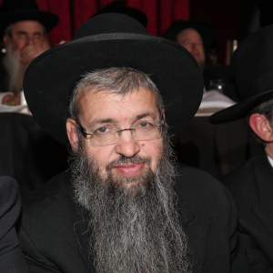

Let us return to our crash course on more powerful prayer.

**Effective Way Number Ten:**

In the beginning of the Torah, we are informed it did not rain yet upon the earth for “V’adam ayin laavod es ha’adomah – There was no man yet to work the ground.” This is perplexing. What does working the ground have to do with rainfall?

Rashi explains that the work the Torah is referring to is the work of the heart, namely prayer, for rainfall comes in response to human prayer. (As an aside, this teaches us the important lesson that when we go to shul, we are not going there to sit back and relax. Rather, we are going there to work, to purge our minds from all distractions and invest effort in concentrating that we are talking to the Almighty.

Rabbi [Berel] Wein, shlit”a, writes that when he furnished his shul in Monsey, he deliberately avoided making the chairs too comfortable. He didn’t want his congregants to lean back. He wanted them to sit up and get to work.) In a metaphorical sense, geshem refers to gashmius, our material success, and it conveys the lesson that our parnassa, our livelihood, also comes about through proper prayer.

This is a cardinal belief. Quality tefillah can greatly enhance one’s take-home pay. The Mabit, in his seminal sefer on prayer Beis Elokim, writes that one can find people who can barely see, get better and start seeing again. So too, those who are mute can start to talk. But, rarely, he informs us, does someone who is a shoteh, who is institutionally deranged, become sane and normal.

He explains the reason. The one who can’t see desperately prays to Hashem for sight. The one who is mute intensely pleads to Hashem for the ability to speak. The one who is deranged doesn’t pray to Hashem because he thinks he’s normal so he doesn’t pray for help – and everything depends on proper prayer.

In a quasi-humorous way, the Toliner Rebbe shared the following witticism. He and the Rachmastrivska Rebbe, shlit”a, are brothers. He was once asked why his brother has many wealthy chassidim while he has mostly a poor constituency. The Toliner Rebbe answered as follows. “My brother has a large chassidus. Each chossid gets very little time to spend with him. Thus, they don’t feel confident with the short time he provides them, so they pray to Hashem and therefore they are successful. I have much fewer chassidim and I spend much more time with each one. Therefore, they put their faith in me instead of focusing on Hashem. That’s why they’re all poor.”

In bentching, we say, “V’na al tatzricheinu, Hashem Elokeinu, lo lidei matnas basar v’dam, v’lo lidei halva’asom; ki im liyod’cha ham’lei’ah, hapesuchah, hakadoshah v’har’chavah – And please Hashem may we not need to take gifts from flesh and blood and not take loans; rather, we should be supported from Your Hands that are pure, open, holy and bountiful.”

For many, this prayer seems to almost be hypocritical. They are supported by their parents, they live in their house and drive cars solely because of bank loans. The Siach Sarfei Kodesh makes this prayer more palatable by rendering the request as follows.

“We should not need gifts from flesh and blood or their loans, except if we realize that they are really coming from Hashem’s Hand which is full, open, holy and bountiful (interpreting the words ki im as a conditional statement).

May it be the will of the Hashem that we realize what a great impact our baruch aleinu, our shma koleinu, and our sim shalom can make in our livelihoods and in that merit may Hashem bless us with long life, good health, and everything wonderful.

Reprinted from the Parshas Vayeira 5780 email of The Jewish Vues.

**Rav Avigdor Miller on**

**How Much to Pay for a Beard**



**QUESTION:** The Chofetz Chaim wrote a *kuntress* about the prohibition of shaving, and other *gedolim* also wrote about the importance of wearing a beard. What should a person do if his wife is not so happy about the idea?

**ANSWER:** What should a person do if his wife doesn't want him to grow a beard? So, if he can afford a diamond ring, so he should invest the money. And if he can't, it's possible, little by little, with diplomacy, to convince her that a beard is a good thing. All things need diplomacy, and if you do it with *chochma* then I'm sure that in the course of time you'll be able to win out.

Now, in the *yeshivos* in Lithuania before Wold War Two nobody had a beard. That's a fact. Only the kollel people had beards. But the *bochurim*, even the old *bochurim*, nobody had a beard. Even in the American *yeshivos*, once upon a time, even the good *yeshivos*, nobody wore a beard. It was only later on, when the *chassidish* element came to this country more and more, it had a very big influence and people began growing beards as a result.

Now, you have to understand that *hadras ponim*, the beauty of a Jewish face, is enhanced by a beard. A beard doesn't take away the beauty of the face; on the contrary, a male face is much more attractive when it has a beard. It's like a woman's hair. A woman without hair on her head, a bald-headed woman, she's not attractive. A Jew without a beard on his face is not attractive.

However, not always it is possible to do it. You might have to be patient. And if you're really interested in having a beard, you can consult somebody more capable of giving advice, and little by little, there are ways of winning her over.

Some people, for certain reasons, don't grow their beards. Maybe they think that there are certain places, certain situations, where they'll have more influence without a beard. And therefore, if it's *l'sheim shamayim*, it could be that it's the proper way to do.

But anything that you want of your wife, first of all דבר תורה מעות קונות, money and gifts always accomplish Torah results. Try it. Maybe you'll succeed.

*Reprinted from the September 17, 2019 email of Toras Avigdor adapted from Tape #E-139.*

**Thoughts that Count for Parashat Chayei Sarah**

*You shall not take a wife for my son from the daughters of the Canaanites* (Gen. 24:3)

Although Avraham's relatives were idol worshippers like the Canaanites, they were not similarly degenerate in the moral sense, a trait passed on from generation to generation.

Avraham's family may have held false religious beliefs, but mistaken ideas are not hereditary. *(Avnei Ezer)*

*Among all of his [Ishmael's] brethren he settled (lit. "fell")* (Gen. 25:18)

With these words the Torah portion of Chayei Sarah concludes, to be followed immediately by, "And these are the generations of Yitzchak, the son of Avraham," the beginning of the Torah portion of Toldot.

This alludes to the ultimate fall of Ishmael in the End of Days and the subsequent triumph of Moshiach, the son of David, who is descended from Yitzchak. *(Baal HaTurim)*

*Then Avraham expired, and died in a good old age* (Gen. 25:8)

On the day that Avraham passed away, the greatest of the Gentiles cried, "Woe to the world that has lost its leader; woe to the ship that has lost its captain." *(Talmud, Baba Batra)*

*Reprinted from the Issue #340 of L’Chaim Weekly (Parashat Chaye Sarah 5755/1994)*

**The Lesson of Rivka’s**

**Betrothal and the Future**

**Redemption of the Jewish Nation**

**From the Talks of the Lubavitcher Rebbe**

**Rabbi Menachem Mendel Schneerson, Zt”l**

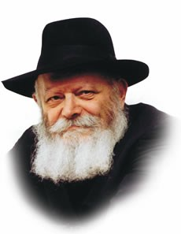

This week's Torah portion, Chayei Sara, recounts the very first marriage match in the Torah.

Avraham sent Eliezer, his faithful servant, to his relatives in Mesopotamia, where Eliezer was destined to meet Rikva, Yitzchak's intended.

Rashi, the great Torah commentator, explains that Eliezer's actual journey was miraculous.

"I have come today," Eliezer declared to Rikva's father and brother, Betuel and Lavan. "Today I set out, and today I arrived," comments Rashi, noting that Eliezer reached his destination -- a journey of 17 days in ancient times -- on the very day he embarked.

Why was it necessary for G-d to make a special miracle for Eliezer? Furthermore, why did Eliezer find it necessary to mention it to Betuel and Lavan?

Rivka, Matriarch of the Jewish people, is described in the Midrash as "a rose among the thorns." Righteous and pure, Rivka lived the first few years of her life surrounded by "thorns," the wicked Betuel and Lavan.

As anyone who has plucked a rose knows, it is not easy to free the rose from its prickly surroundings. Indeed, the thorns exist solely in the merit of the rose, for it is because of the rose that the gardener cultivates and nurtures the plant.

Similarly, the holy Zohar describes the spiritual struggle exerted by the forces of evil against the pure and G-dly soul of the Jew. For, like the thorns, these forces derive their sustenance precisely in the presence of the greatest holiness.

Betuel and Lavan rightly understood that it was in Rivka's merit that their household had been blessed, and were reluctant to allow her to leave.

For the first three years of her life, too young to be successfully transplanted to the holy environment in which she belonged, Rikva was surrounded by un-holiness.

On the very day she turned three, when -- according to Jewish law she could be betrothed -- Abraham sensed that the proper time had arrived to free the rose from its prickly environment.

Eliezer was dispatched without delay, and a miracle was wrought so that Rikva would not have to spend even one extra moment in an improper atmosphere.

Eliezer's task was to convince Betuel and Lavan that G-d had destined Rivka to be Isaac's wife, and that they had no power to prevent her departure.

"I have come today!" he declared, knowing that they would try to delay her leaving. "Destiny cannot wait! Today I have come, for I must bring her back with me at once!"

"The deeds of the fathers provide instruction for their sons," our Sages teach.

From Eliezer's journey we learn that when the moment for Redemption arrives, it cannot be delayed for even one second.

If need be, miracles will be wrought to ensure that the Redemption occurs at exactly the proper time.

We must therefore not be disheartened by the length of our present Exile, for just as the Jewish people were redeemed from Egypt "on the selfsame day" when the exact moment for liberation arrived, the Final Redemption with Moshiach will likewise take place immediately and without delay at the proper time, speedily in our days.

*Reprinted from the Issue #340 of L’Chaim Weekly (Parashat Chaye Sarah 5755/1994)*

**Rabbi Berel Wein**

**On Chayei Sarah**

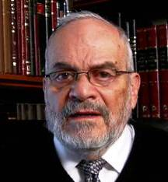

It is very difficult to sum up the experiences, worth and influence of an individual purely in words. That is why many times at funerals people who hear eulogies of the deceased feel that somehow the words of the tribute really did not capture the essence of the individual being memorialized.

In the Torah reading this week, Abraham is said to have eulogized his beloved wife Sarah. The Torah does not describe for us the words that he used in speaking about her. However, Rashi, in commenting as to why the Torah listed her life as consisting of 100 and then 20 and then seven years, states that all of her lives – the one that was 100, the one that was 20 and the one that was 7 – were devoted to goodness.

 That simple statement is the true eulogy for our mother Sarah. Everything was for the good, and, therefore, all her life was devoted to being and creating good for her family and for others. When people say that the person was "a person of goodness", that phrase encompasses many details and many actions.

However, enumerating an individual's actions of goodness is really unnecessary, because we understand what a person of goodness is and does. This is a state of mind, an emotion of the soul that drives human behavior and actions. When we say someone was or is a good person everyone immediately knows what is meant by that statement, and, therefore, no further explanations or illustrations are necessary.

We often mistakenly associate the trait of goodness with a certain weakness of character and a compromise of willpower. We think that good people must automatically be soft people, and in a world that is often harsh and hard, softness is not always a virtue.

Nevertheless, when we review the life of our mother Sarah, we cannot help but be impressed by the fact that she was a strong-willed and powerful personality. She took severe and painful steps to safeguard her son Isaac from the ravages of his half-brother Ishmael.

Even when her husband Abraham seemed to be in doubt as to how to treat the matter, she stayed firm, and, eventually, the L-rd, so to speak, told Abraham to listen and obey whatever Sarah instructed him to do. Goodness should never be seen as weakness. Rather, it is to be seen as the search for the ultimate benefit the person himself or herself and for the general society. In a good society, justice is done, and corrective measures are taken to make certain that evil will is not allowed to flourish or go unpunished and unchallenged.

This is the type of world that Abraham and Sarah were striving to build, and it was the influence of their personalities that marked their generation and gave it a stamp of goodness and purpose. That task of accomplishing goodness has been the challenge to the Jewish people for millennia and remains our mission and goal in our time as well.

*Reprinted from this week’s website of Rabbiwein.co*

**Rabbi Eli J. Mansour**

**On Parashat Chayei Sarah**

Parashat Chayei Sarah tells of the death of our matriarch Sarah, Avraham's wife.  Sarah was originally named "Sarai," and only later (Bereishit, chapter 17) did G-d change her name to "Sarah."  What does the name "Sarah" signify, and how does it differ from "Sarai"?

The Rabbis explain that the word "Sarai" means "control over the individual," in the singular form, whereas "Sarah" means "control over everyone."  G-d called Sarah by this name to indicate that she controlled the entire world, that her control and dominion had no limits.  The obvious question arises, over whom exactly did Sarah exert control?  She wasn't a queen; she had no monarchal power or authority over other people.  How, then, are we to understand the name "Sarah," the reference to her unlimited control?

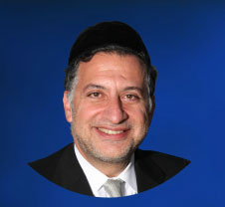

The answer is that she controlled the world, rather than allowing the world to control her. Life is full of crises, challenges and trials, and most people lack the fortitude to properly confront and deal with these situations. We often buckle under pressure and lose control over our lives. Rather than retaining our composure and seizing control, we become victims of the world, of our own lives.

Sarah most certainly had a crisis-ridden life. There is no need to describe the pain and frustration of ninety years of infertility. And yet, throughout the years of anguish and disappointment, she managed to maintain her dignity, the warm hospitality extended to her many visitors, and the aura of peace and serenity in her home.

What more, twice Sarah was kidnapped. Both in Egypt and in Gerar, she was abducted by force, brought to the king without her consent. Such an experience – even had it occurred just once – would normally break a person's spirit and send him or her into despair and perhaps even dysfunction. But Sarah was a woman of control and dominion. She controlled her life, and refused to allow these otherwise traumatic experiences to overcome her.  She triumphed over hardship and frustration, rather than fall victim to them.

How does one achieve such control?  From where does a person like Sarah draw the strength to overcome the vicissitudes of life and retain his or her control and composure?

The answer, most likely, is that this power stems from the belief that nothing in the world happens by chance; it all happens by design. G-d never makes a mistake; there is no such thing as an angel misunderstanding instructions, or as something that occurs to the "wrong guy."

The Almighty knows what He is doing, even when we cannot see or understand why things happen as they do – and we often don't. If we firmly believe that G-d's hand lies behind all that transpires, we won't break, we won't lose our control. We will instead have the confidence to confront the challenges of life and overcome them, knowing that it is G-d who presented us with these challenges for a particular purpose.

Indeed, this can be seen in Sarah's own life. The Torah tells that G-d punished Avimelech, king of Gerar, for abducting Sarah by afflicting him and his entire household with infertility, and He demanded that Avimelech beseech Avraham to pray on his behalf for this disorder to be cured.

And the Gemara says that because Avraham, who himself longed for a child, prayed that Avimelech and his household be cured from infertility, he was himself blessed with a child. Yitzchak was born after – and as a result of – Avraham's prayer on behalf of Avimelech.

It turns out, then, that Sarah was blessed with a son as a result of her abduction by Avimelech. Such a painful and frightening experience ultimately yielded the fulfillment of her wishes and prayers of ninety years.

Not always will we understand why things happen in life as they do, but by firmly believing, as Sarah did, that everything is carefully designed by G-d, and that only He knows what is best, we, too, can take control over life, rather than allowing life take control over us.

*Reprinted from this week’s website of the Edmond J Safra Synagogue of Brooklyn website.*

**The Shmuz onParshas Chayei Sarah**

**The Greatness of the Avos**

**By Rabbi Bentzion Shafier**

**Founder of TheShmuz.com**

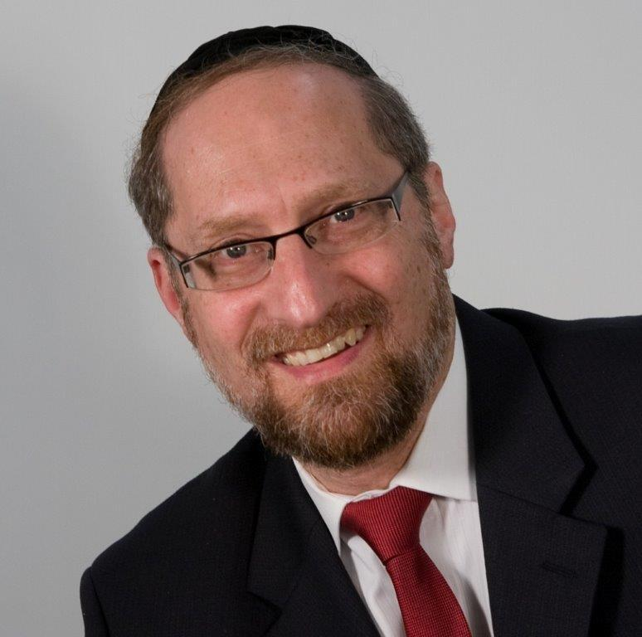

“*And Sarah died in Kiryas Arbah, which is Chevron, in the land of Cannan, and Avrohom came to mourn for Sarah and to cry for her*.” — Bereishis 23:2

Every word in the Torah is exact and every nuance measured. Therefore, Rashi is bothered that the Torah places the burial of Sarah next to the Akeidah. There doesn’t seem to be any connection between the two events. Rashi answers that the Torah is teaching us that it was through the Akeidah that Sarah died.

The Medrash tells us that after the Akeidah, the Soton came to Sarah and said, “Did you hear?”

“No. What?”

“Oh… well… you see, Avrohom took Yitzchak with him to Yerushalayim to the very place where the Bais HaMikdash will be built. He built an altar right where the Mizbeach will one day be. He tied Yitzchak up, hands behind his back, and put him on that altar. Then Avrohom prepared the wood and everything else needed to bring a korbon. He took a long knife, held it over Yitzchaks neck, moved his hand down…”

Before the Soton could continue, Sarah’s nishomah left her and she died.

The Taz on this Rashi explains that when Sarah heard the words of the Soton, she imagined the pain and terror that Yitzchak must have felt at that moment. It was too much for her to bear, and that caused her death.

This Rashi is quite difficult to understand. Sarah Imeinu was a strong, emotionally stable woman. In fact, she was a like a rock. She had unshakable bitachon, having lived through many trials and travails. More than that, while all the Imahos matured at a very young age, Sarah was 127 years old at this point, not a flighty teenager.

It seems difficult to understand how she could die from feeling the pain of her son. But even more, her son was not a toddler. At the time of the Akeidah, Yitzchak was 37 years old. He was a fully grown man. How is it possible that this news caused her so much pain that she literally died from it?

This question can best be answered by understanding the dynamics of the human personality.

**Parental Instinct**

In the wild, a mother cougar will risk its life to save its young. A mother bear becomes ferocious and almost uncontrollable when her cubs are threatened. In many species, we see a powerful maternal instinct to protect offspring, and this lasts till the young are about two years old.

Then something strange happens. The same mother, who would risk life and limb for her litter, will turn against the now-grown cub and force it out of the group. The cub is no longer recognized as something to protect, but as a competitor to be shunned and chased out. The motherly instinct served its purpose. When it is no longer needed, it shuts off like a water spigot.

We see an eerie parallel in the world of man. If you go to your local hospital and look in at the new fathers in the nursery, you will witness very tender scenes. When Frank, the UPS driver, picks up Frank Jr. for the first time, there is a look of love and devotion in his eyes. You can almost hear him planning out their future. “Me and Frank Jr… we are going to be tight. We are going to play ball together, go to hockey games together. It’s going to be great.”

And it is, for a while. . . but then Frank Jr. hits the teenage years and it is no longer so beautiful. In fact, they are no longer speaking to each other. No longer does Frank dream about spending time with his child, no longer does he yearn for that relationship. It might be the farthest thing from his mind. What happened?

What happened was that Frank Jr. stopped being the little babe lovingly looking into his father’s eyes, and the relationship took on a very different nature. When the natural instinct begins to wane, a very different relationship ensues.

**A Father Feels the Pain of His Son**

The Chovos Ha’Levovos tells us that HASHEM implanted into the human heart all of the instincts needed for survival of man. One of these is the parental instinct. The father didn’t ask for this sensation, nor does he control it, but he feels the pain of his child. In fact, if the son is cut, the father feels it as if it his own flesh that is being cut.

This is an instinct that HASHEM put into parents to give them the drive to care for and protect their young. However, that attachment doesn’t last forever. As the child matures and becomes his own person, the parent still loves the child, but there is a change in the relationship.

This instinct is much like the sulfur on a kitchen match. When you strike it against the phosphorous on the matchbox, it will ignite into flame. It gets very hot, very quickly. It flares up for a second or two, long enough to light the wood of the match. However, that flame wasn’t designed to last. If the match is wet, the flame will soon flicker and die. It was only created to be a catalyst to start the fire, not to keep it going.

The instincts that HASHEM put into man will cause him to care for his offspring when they are young and in need of great attention, but that sense soon fades. If the person is a giving, caring individual, that initial burst will be enough to be the catalyst to real attachment, and the bonding will continue and deepen as the flame of love grows. If the wood is wet or rotten, the flame will weaken and go out.

This seems to be the answer to the question. The heart of the tzaddik is pure and is filled with love and affection. Sarah worked on herself to such an extent that she was completely other-centered. Her whole existence was focused on helping others, taking care of their needs, and doing for them.

When she had her own child, the natural maternal instinct flared and caused a bond and attachment to her child that was unbreakable. But that sense didn’t fade as the years passed. Because her heart was so pure, it increased and became more powerful so that she and Yitzchak were as one. It was to such an extent that when she heard the news that her precious child was in pain, the thought was too much for her to bear, and she literally died.

This concept has powerful ramifications in our own lives. For parents to become true advocates, protectors, guides, and mentors to their children, they must foster this bond and allow it to grow up with their child. The instinct will only take them so far. After a point, it is their own dedication and devotion that takes over and creates the true bond. While we will never reach the level of the Avos, they remain for us guiding lights to show us the dynamics of the human personality and the heights that a human can aspire to.

*Reprinted from this week’s website on TheShmuz.com This is an excerpt from the [Shmuz on the Parsha book](https://theshmuz.com/product/shmuz-on-the-parsha-book/).*

**A Torah Guide for Jewish Women in the Workplace**

**By Daniel Keren**

(“Making it All Work – A Practical Guide to Hashkafah and Halachah in the Workplace: Women Surviving and Thriving at Work” by Ari Wasserman with Miryam Wasserman with foreword by Rebbetzin Tziporah Heller, 485 pages, distributed by Feldheim Publishers, 2019)

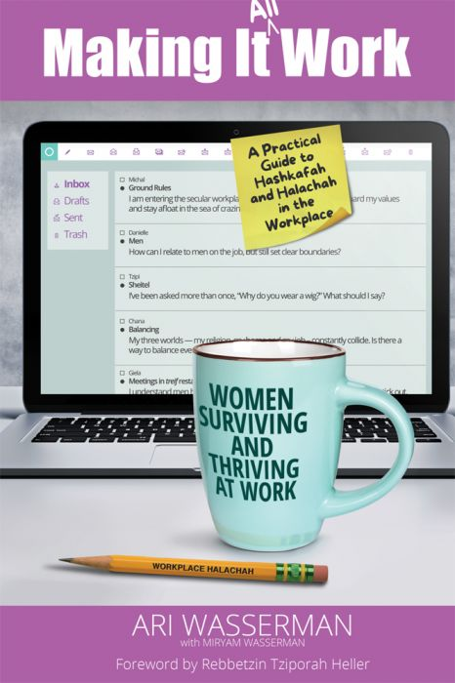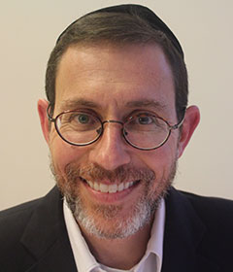

**Ari Wasserman, author of “Making it All Work”**

How should a Jew behave in the workplace? One can either demonstrate an incredible Kiddush Hashem (sanctification of Hashem’s holy Name) or unfortunately the opposite – chillul Hashem. When a Jew (especially an obviously religious observant member of the Tribe) performs at work, he or she is judged by others as a representative of the Jewish nation.

Ari Wasserman has just had published a special guide for Jewish religious women titled “Making it All Work – A Practical Guide to Hashkafah and Halachah in the Workplace: Women Surviving and Thriving at Work” that is a companion to his 2016 book for men titled “Making it Work: A Practical Guide to Halachah in the Workplace.”

**Many Unique Issues for**

**Women in the Workplace**

In his introduction, Ari Wasserman notes that his research demonstrated that Jewish women in the workplace have many issues that are unique to them, problems that men never encounter. Therefore with the exception of a few overlapping chapters, most of his new book for women is brand new.

A graduate of Yeshiva University in Los Angeles, he later attended Yeshivat Sha’alvim in Israel before earning a bachelor’s degree in business from the University of Pennsylvania and a law degree from Harvard Law School. He practiced law for a top-rate law office in Manhattan for five years before moving back to California.

This new book for Jewish women in the workplace was to a certain degree inspired by the challenges of his own wife Miryam who graduated from Stern College division of Yeshiva Univesity. Today the Wassermans live in Israel with their children.

In addition to haskamos from respected rabbis from both the chareidi and modern Orthodox communities, the Wasserman’s new book also includes a foreword by Rebbetzin Tziporh Heller titled “The Heroic Working Woman” and approbations from Rabbanit Yemima Mizrachi an Rebbetzin Feige Twerski.

**Different Challenges in Secular**

**And Even Religious Workplaces**

There are dozens if not hundreds of challenges and problems that can confront a religious Jewish women regardless of whether her workplace is secular (non-Jewish or as is common in Israel – assimilated Jewish) or even religious.

“Making it All Work: Women Surviving and Thriving at Work” is broken into six distinct parts (“Going Out to Work,” “Getting it All Done,” “Dealing with Men,” “Socializing On and Off the Job,” “Maintaining Kedushah” and “Staying Connected”) as well as 32 more specialized chapters.

The chapters tackle such issues as the juggling act of balancing work, religion and home life; is a husband obligated to help at home, socializing on the job, the special challenges of a frum workplace, special issues of working in healthcare, attending office parties and gatherings, avoiding vulgar speech in the workplace, the prohibition of yichud, shaking hands with men and davening on the job.

Much of the book is based on emails that Mr. Wasserman received from dozens of women in both the United States and in Israel in response to a request by Mishpacha columnist Jonathan Rosenblum for his female readers to share their experiences with Mr. Wasserman.

**The Dangerous Challenge of Attending**

**Office Parties and Gatherings**

A sample of the responses that Mr. Wasserman received can be found in the chapter dealing with attending office parties and gatherings. One woman wrote:

“I was once employed by a predominantly non-Jewish marketing company that had a few other Jews on the staff. At the end of every year, they held a generic ‘holiday party’ at an event hall, without ascribing it specifically to any non-Jewish holiday (be it Christmas or New Year’s and, presumably the Jewish employees were welcome to view it as a Chanukah party.)

“As the company’s general counsel, I was able to establish that there would be no alcohol served to avoid safety issues for those driving back from the party. But I was not able to get around the problems of socializing and non-kosher refreshments.

**The fear of Offending One’s**

**Employer and Coworkers**

“I would have been happy to find a way out of attending, but I feared offending my employer and coworkers. In addition, bonus checks were given out at this affair and showing up was the way to get the check.

“I consulted Rav Gerson Bess, who said that I could attend and collect my check on the condition that I would not stay too long. In fact, he advised that I remain standing the entire time, rather than sitting down and settling in, which is what I did.”

“Making it All Work: Women Surviving and Thriving at Work” by Avi Wasserman with Miryam Wasserman can be found in Jewish bookstores or by contacting the distributor by either calling (845) 356-2282 or clicking www.feldheim.com

*Reprinted from the November 14, 2019 editionl of The Jewish Connection.*

**Rabbi Yisroel Goldstein Steps Down From Chabad of Poway**

**By COLlive Reporter**

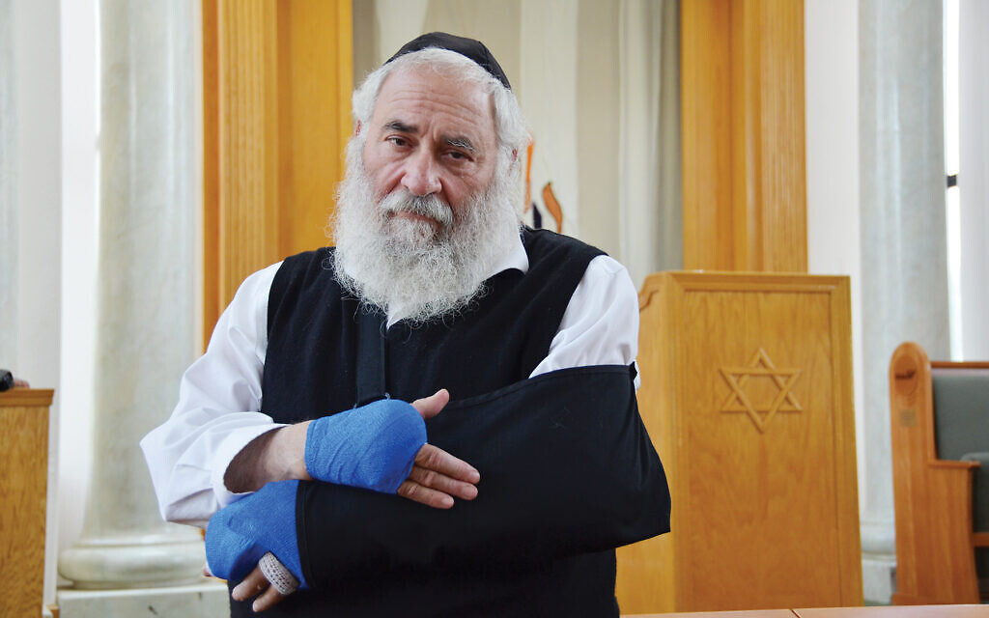

Rabbi **Yisroel Goldstein**, injured in a shooting attack at Chabad of Poway in California which he founded, is stepping down and will assume the title “rabbi emeritus.”

“It was a really rough year and then he immediately made himself a spokesperson,” said **Elisheva Green**, a community member who is active with the local Friendship Circle for people with special needs. “He needs some downtime now. He’s really exhausted.”

Rabbi Goldstein was thrown into the spotlight after an anti-Semitic gunman entered Chabad on April 27 – the last day of Pesach. 60-year-old **Lori Kaye** was killed and three others were injured, including Rabbi Goldstein who lost a finger.

In a show of strength, Rabbi Goldstein remained present during the attack and delivered positive messages to heartbroken community members, to the international media, at the White House alongside President **Donald Trump** and at the United Nations.

**Priya Sridhar**, a reporter for PBS and NPR stations in San Diego, reported that Rabbi Goldstein’s decision to step down “from his day-to-day duties” is “related to PTSD (Post-Trauma Stress Disorder) he has from the incident.”

One of his five sons, Rabbi **Mendel Goldstein**, has assumed leadership of Chabad of Poway, founded in 1986, including its synagogue and school, the Los Angeles Times reported. Another son, Rabbi **Shuie Goldstein**, and his wife, **Devorah Goldstein**, took charge of the Friendship Circle.

“We are grateful for Rabbi Yisroel Goldstein’s thirty-plus years of leadership, especially in the aftermath of the terror attack, and he will forever be a part of our community’s story,” Chabad of Poway said in a statement Friday. “We are thrilled to have Rabbi Mendel Goldstein take the reins of our center, and have great confidence in his skills and ability to lead. He has served the community since 2015, and comes to the position with years of experience and a contagious enthusiasm.”

The Los Angeles Times said that Rabbi Yisroel Goldstein experienced phantom pains from where his right index finger had been shot off. His left index finger, shattered by a bullet fragment, required surgeries and physical therapy.

“Demands on his time became so overwhelming that he stopped giving interviews and even declined the chief rabbi of Israel’s invitation to speak in Jerusalem,” the newspaper reported.

“As a community, we have suffered a great deal, more than any community should know of,” a statement from Chabad of Poway said. “We are working hard to heal and get back on our feet, and now, under the leadership of Rabbi Mendel Goldstein, we look forward to continue to grow and create more light and goodness around us.”

*Reprinted from the November 17, 2019 website of Collive.com*